Dediapada- A paradise for Nature lovers

Are you a nature aficionado? Do you take regular breaks from the hustle and bustle of clamorous megacities? Do you love to be lost in the lap of nature where there’s no disturbance or interference of worldly problems? Then there is an exact site fulfilling your needs. **Dediapada, Gujarat.**

Dediapada is a small town located on the borders of Gujarat and Maharashtra. It is a four-hour drive from Ahmedabad and two hours from Vadodara. Dediapada is a bear sanctuary and national park. Though you will find them in rare cases.

The other day, mumma saw a post on Facebook regarding a trek to Dediapada hosted and managed by a youth-run company called *discover Dediapada.* She managed to convince us to go in this venture. We registered ourselves online and paid the fees to the company head’s bank account prior the trek. It was a weekend journey starting from Saturday morning and ending on Sunday evening.

There are two to three ways reaching there. One way is to opt government managed buses and the second one is if you are planning to advance there by your own car, then follow this below-mentioned route

Ahmedabad-Vadodara-Kelanpur-Dabhoi-Malpur-Rajpipla-Dediapada.

We boarded at dawn. With melodious highway songs in the background and sweet sensible talks of Mumma and Dad, the journey became more pleasant. After reaching there in the afternoon, we came to know that our destination didn’t come yet. We were about 25kms far from our actual trek base camp. The expedition ahead was more joyful and as we stretched our eyes to the horizon, it was all covered with lush green trees. Our car passed through the canopy of huge trees that made a tunnel-like appearance above the roads. After passing some kilometers, we entered the core sanctuary area. It was like entering into another world while switching off the connections from the outer world. The mountains and greenery engulfed us within them.

Our first stop was an edifice of Hanumanji which was erected beside a bumpy road on our way to base camp. The scene and the place was a pure bliss. Blended with the essence of spirituality, a shower of water just behind the temple was a place where whoever wants to enjoy bathing can do. Though we didn’t have that much of time, we headed for our base camp.

Basecamp. We parked our car under the shadow of a tree and stood on the grounds. Observing the surrounding, made our decision to visit that place, totally correct. With the river murmuring between the roads and opposite side shore, the mist surrounding us was satisfying.The best thing was there were no mobile tower connections in all our phones- entirely away from the world.

As I scrutinized a moment, I realized there’s no way to the other side of the river. When asked the instructor, he pointed his finger towards the river, that means *welcome to the trek.*

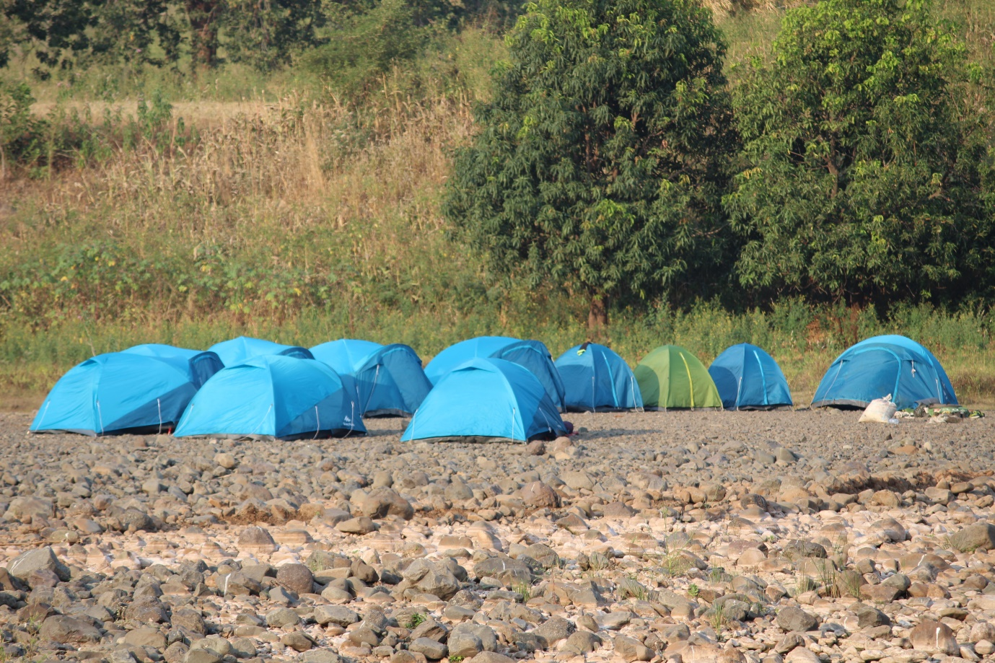

Figure 1Base camp

They had made their kitchen with the help of bamboo and leaves which looked like a medieval aged man wearing leaves as his outfit. Everyone including my family experienced a true sense of mother Earth. After dinner, we reached the base camp crossing the knee-deep river running between. Phone flashlights and batteries played important role in our first venture that night.

We all settled in our respective tents allowed. There was a barbeque party at night in which everyone introduced themselves to other participants. We all woke up before sunshine the other day to mesmerize the process of the sun rising atop the mountains.

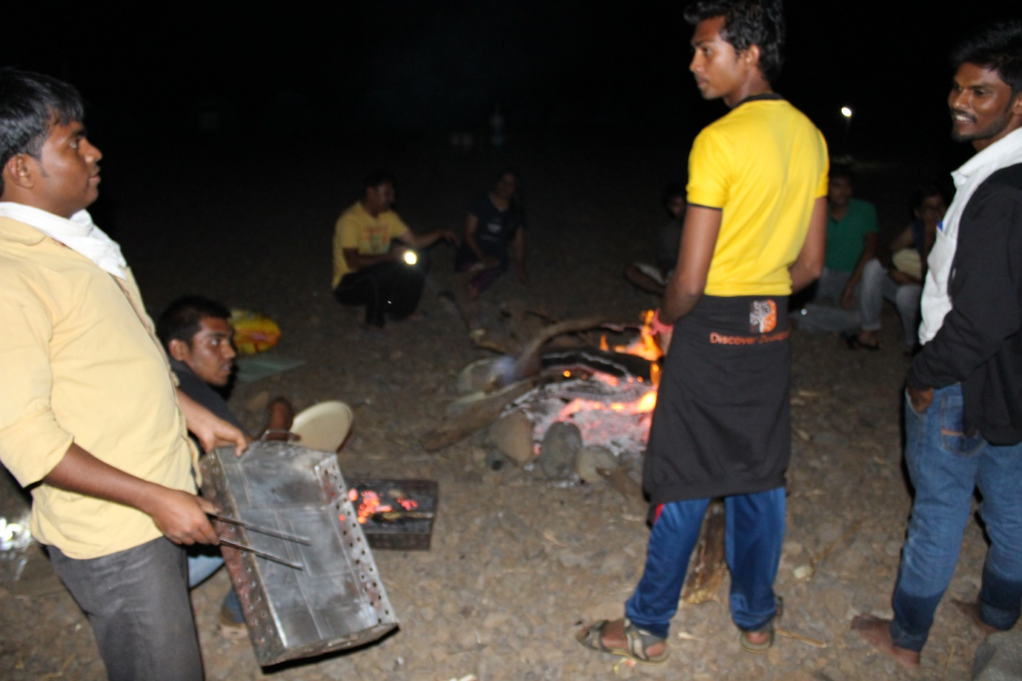

Figure 2Camp fire and barbeque party

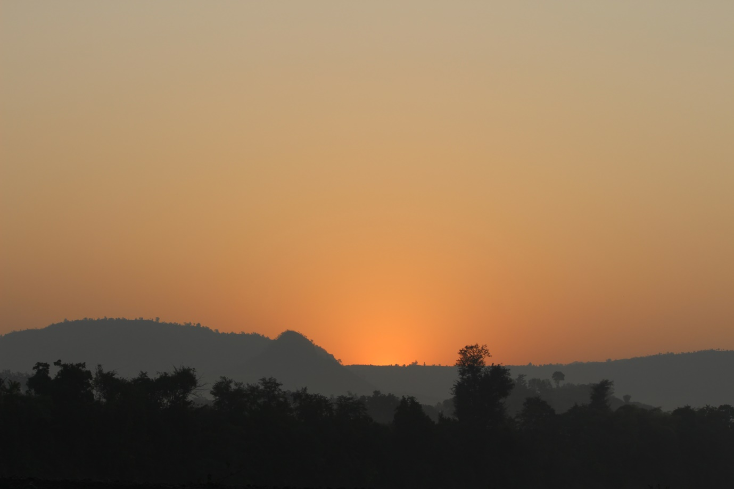

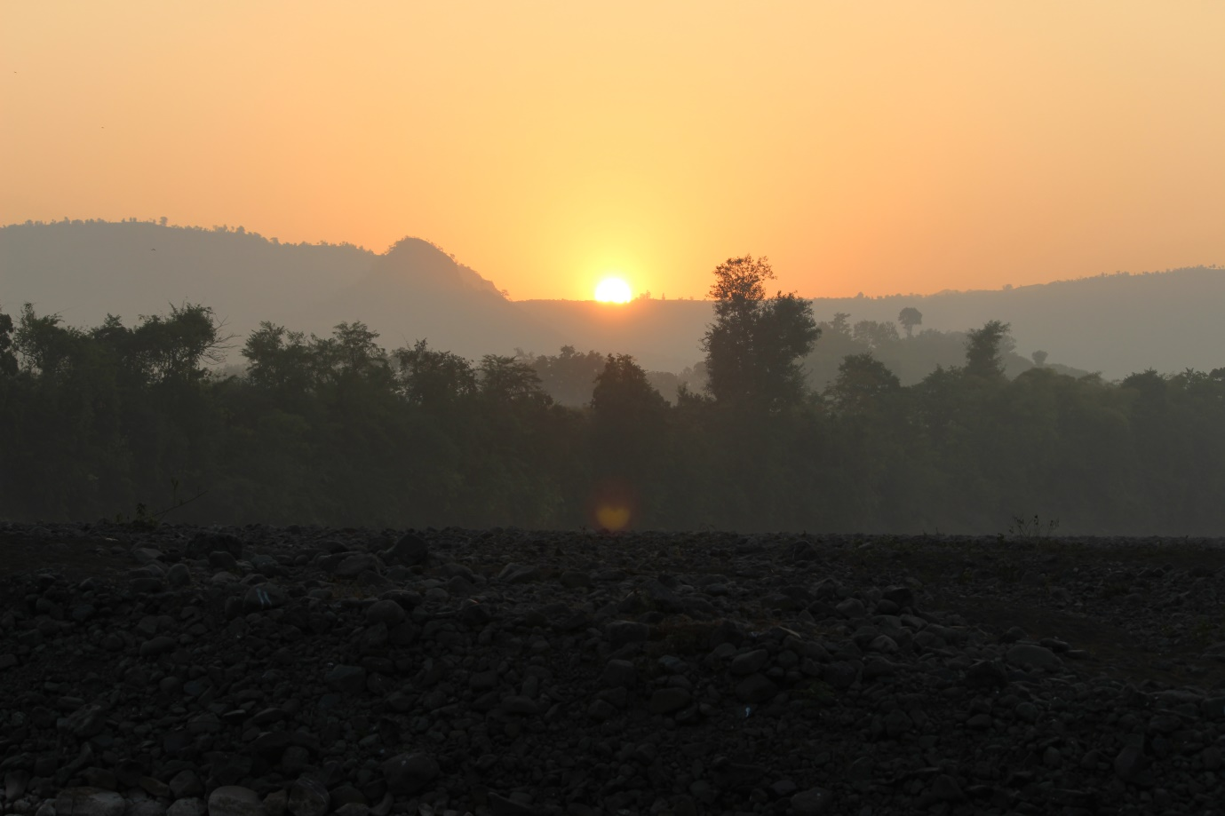

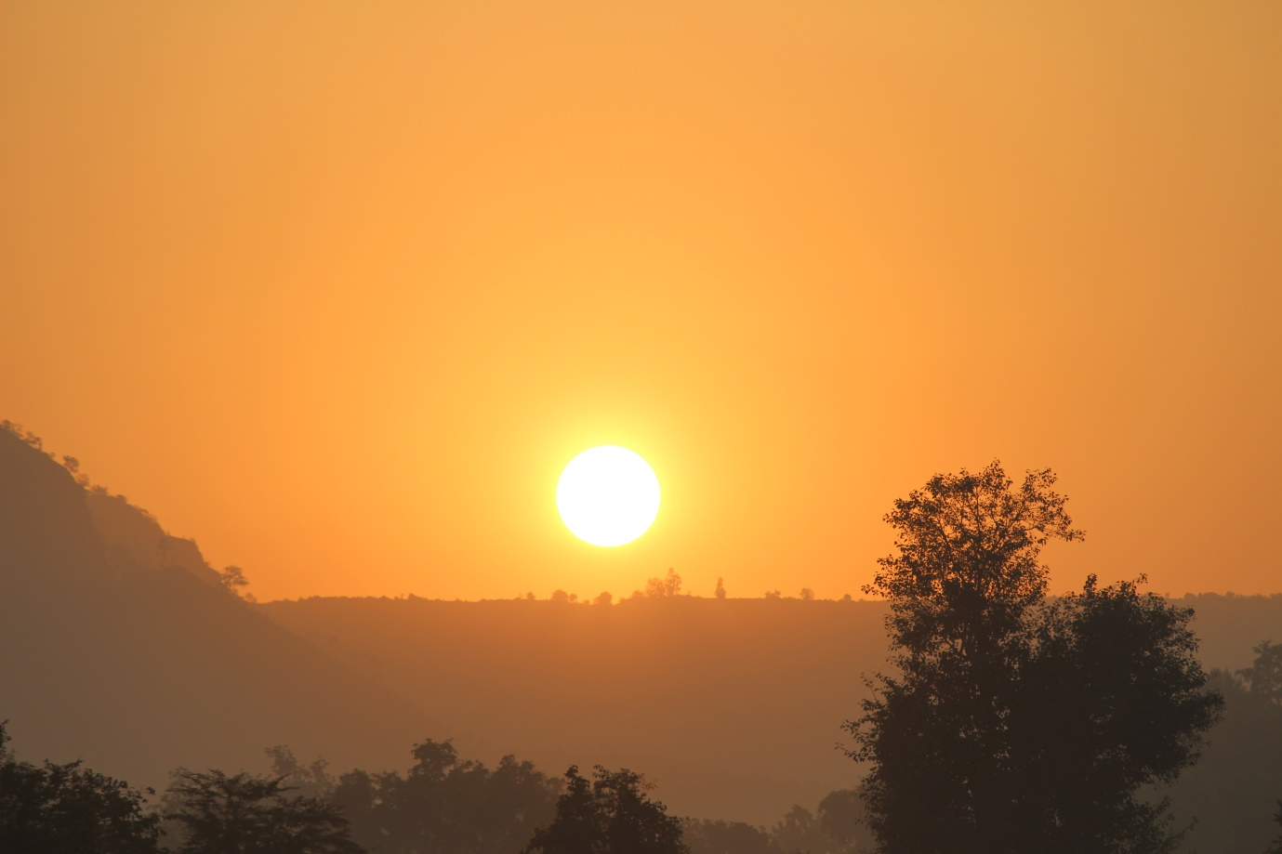

Figure 3The sunrise

Our trek started at 8 in the morning. Our destination was Saribar waterfall 6 km from base camp. Nature started showing it’s true colors, accompanying us were cyclists, a bunch of freelance trek people, chirping birds, green farms ready for harvesting, small streams of river playing with the stones around them.

I don’t remember any simple straight roads to the destination. We crossed the river many times. We were feeling like playing Takeshi’s castle in real life. Have you seen farms in Europe? Lush green, clean, a small hut in the corner for it’s a farmer, a tractor, and periphery filled with the façade of huge trees. Yes, the exact farms were witnessed by us, crossed by us.

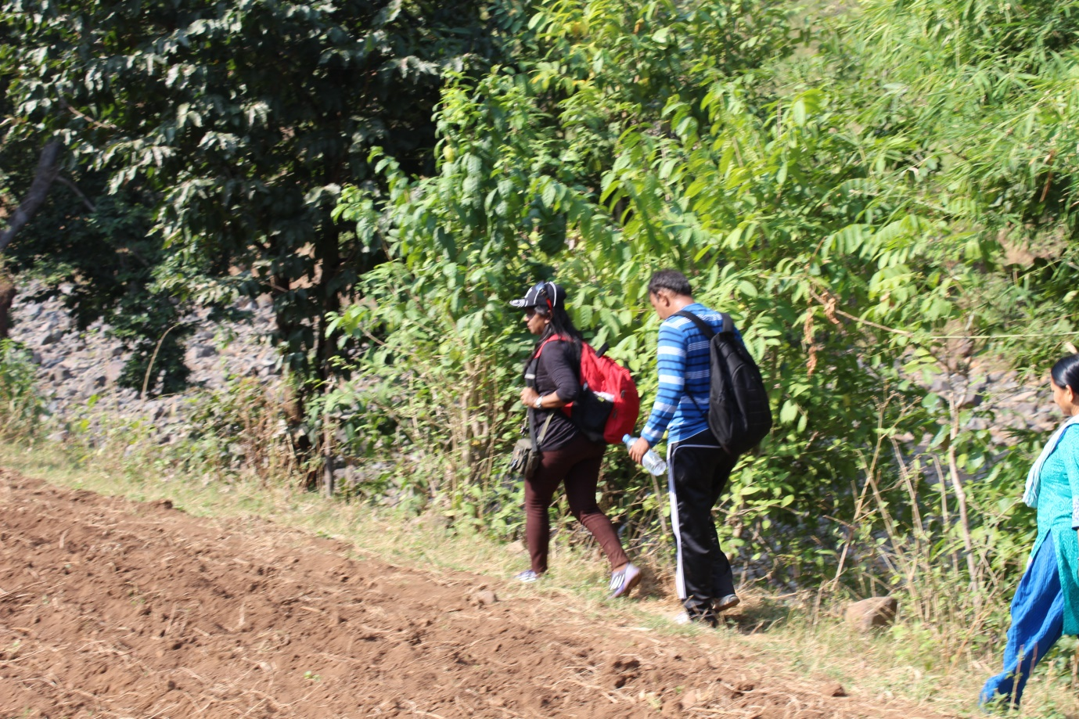

Figure 4Mom and Dad passing through a farm

If anybody likes micro photography then this trek is heaven for them. We came across many of the small living beings of different breeds, from colorful butterflies to black beetles. We took several breaks in between just to hydrate ourselves and regain our energy. The journey ahead was more spectacular. We had our lunch on a large stone, with a small fall on the right side and a pool made out from the fall on the left.

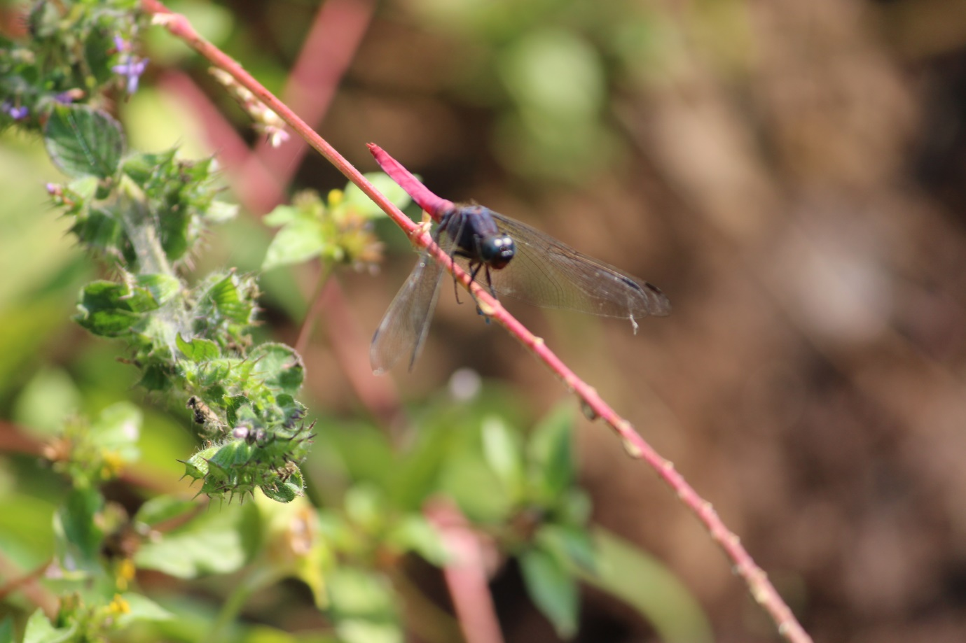

Figure 5Micro photography

The way to our lunch place was like if one wrong leg kept and the person will kiss the water straight away. This was a state of an utter adrenaline rush.

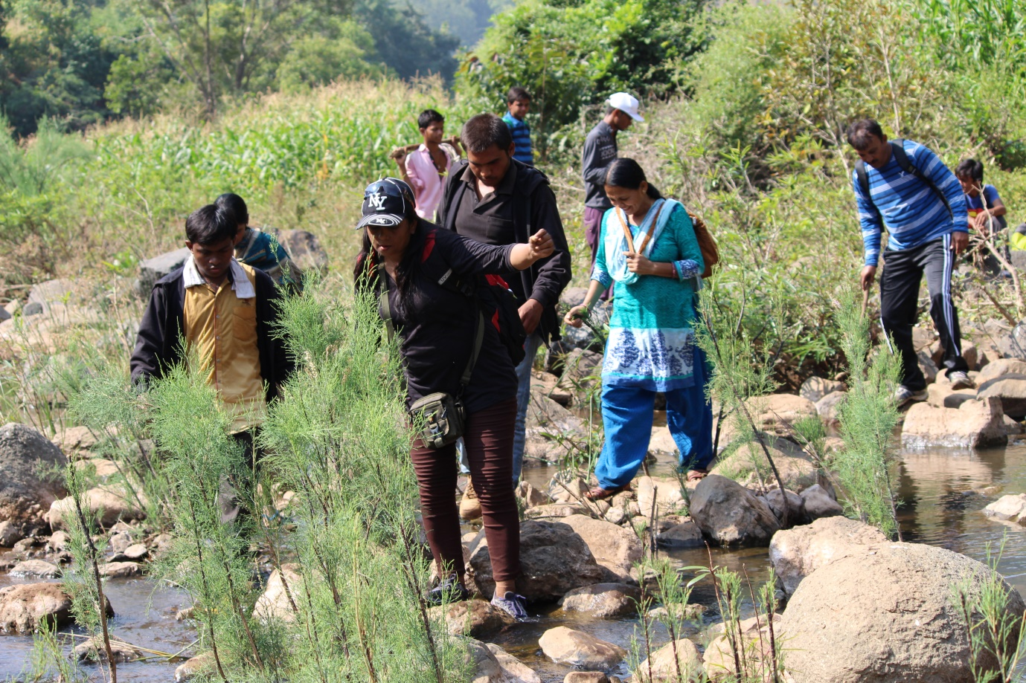

Figure 6Watch out for small torrents coming in between.

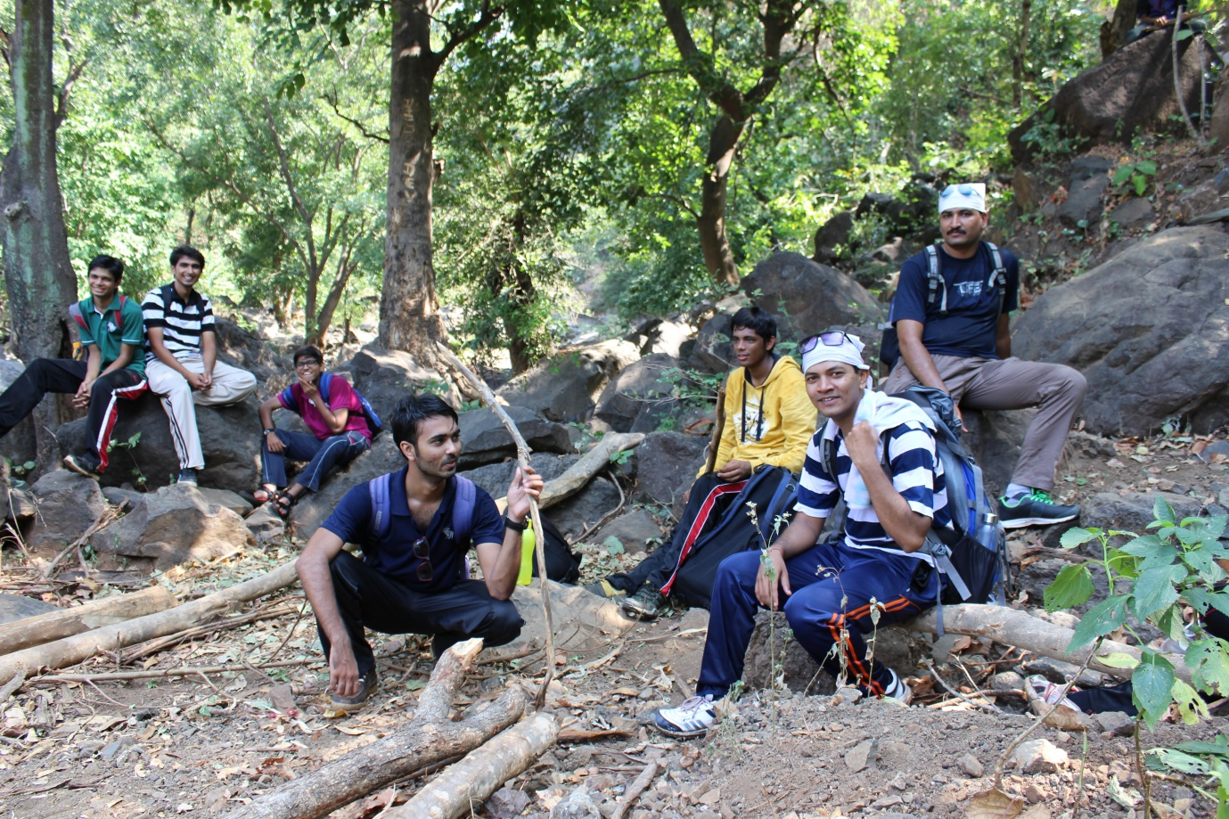

Figure 7Lost in the woods

After we came near the fall, our ears sensed the slight muffling sound of water falling from a considerable height. In no time we all boys splashed in the freezing cold water. The whole vicinity was like the waterfall from Baahubali movie came in reality. If I am wrong, check this out:-

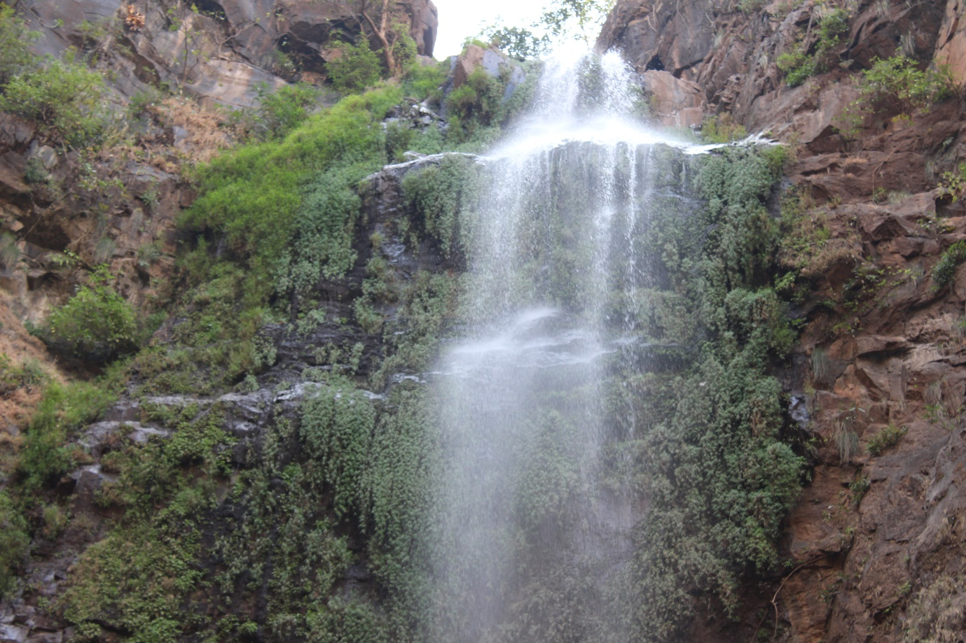

Figure 8The destination

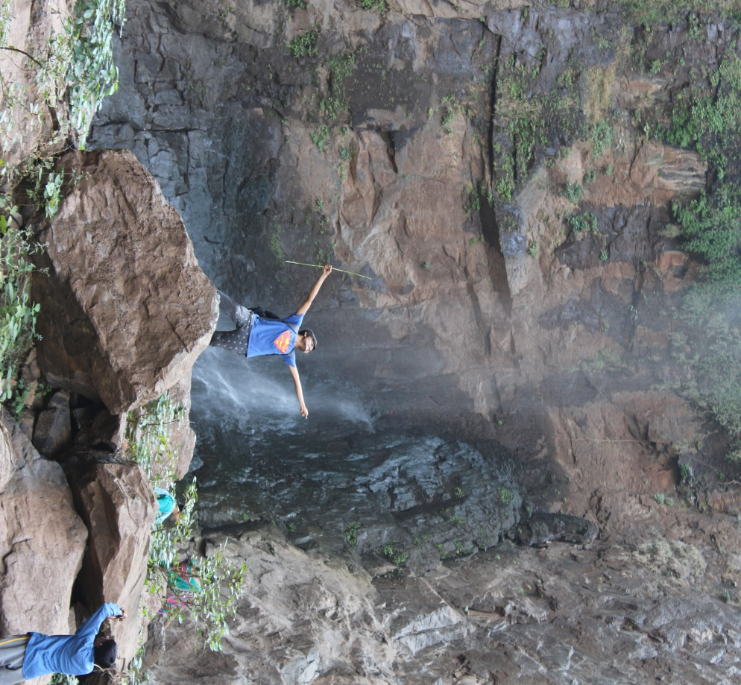

Figure 9The world is mine! This is not me :)

Things to take with you:

1. Torch
2. Empty lunchbox
3. Water bottles
4. Goggles
5. Sports shoes
6. Track pants
7. Camera
8. And other miscellaneous things according to your use.

*Happy trekking!*